**Phase_2 Screenshots**

**Kitchen Story**

Screenshots :

# Fig 1.1 Login Page

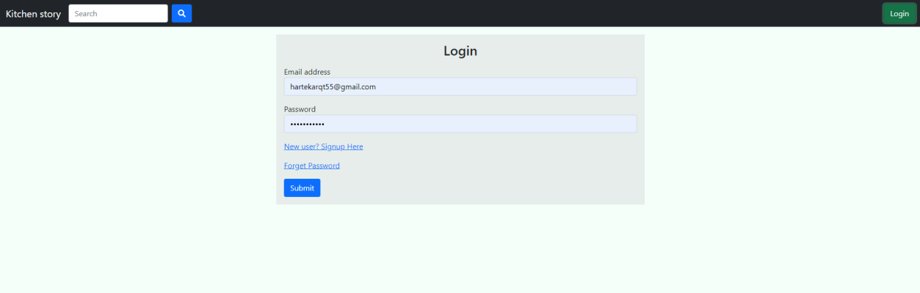

Fig 1.2 Signup page

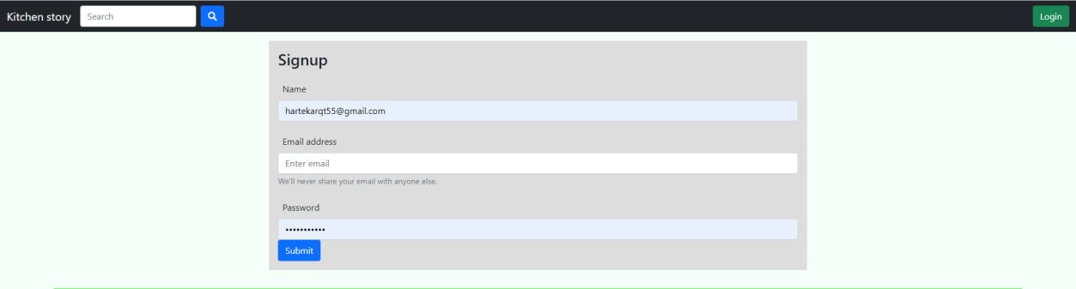

Fig 1.3Home page

Fig 1.4 Product Detail Page

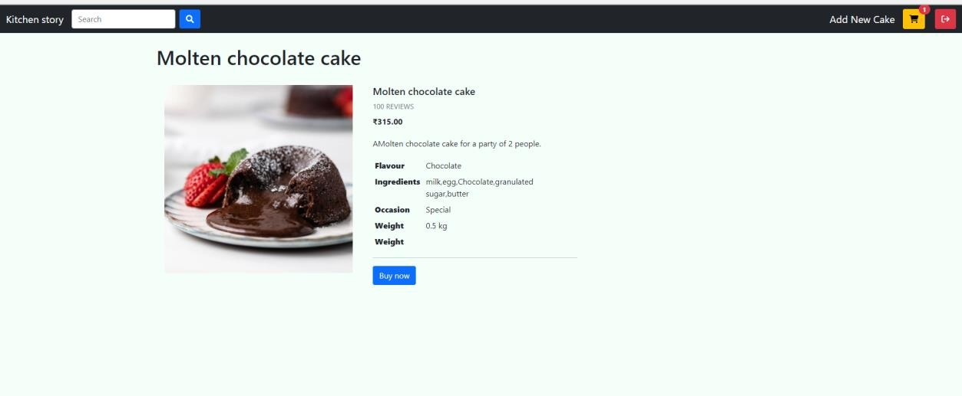

Fig 1.5 Cart Page

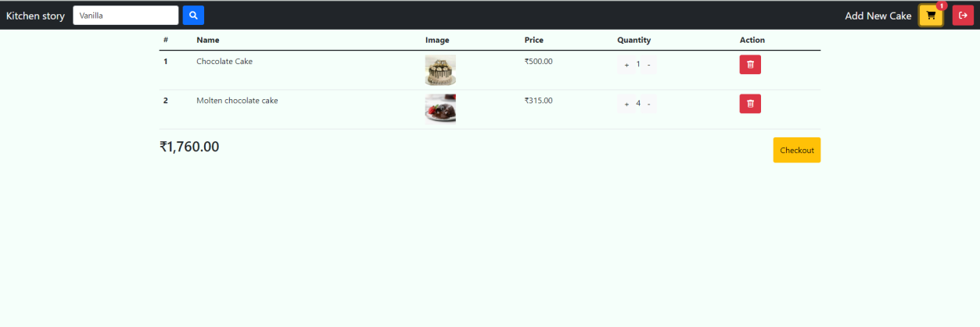

Fig 1.6 Checkout page Address form page

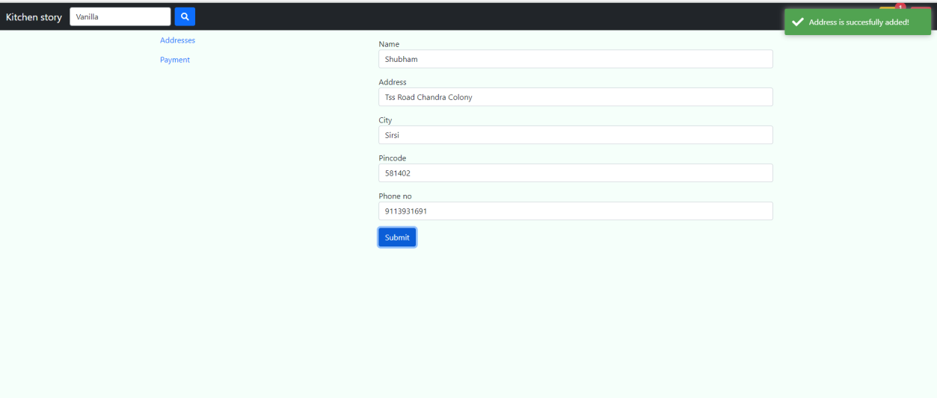

Fig 1.7 Checkout Payment Page

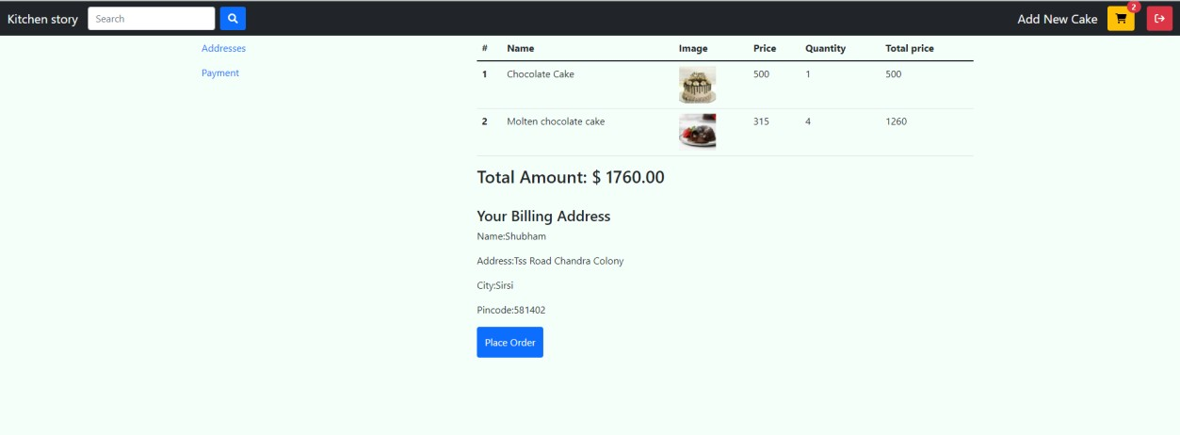

Fig 1.8 Add Product Page

